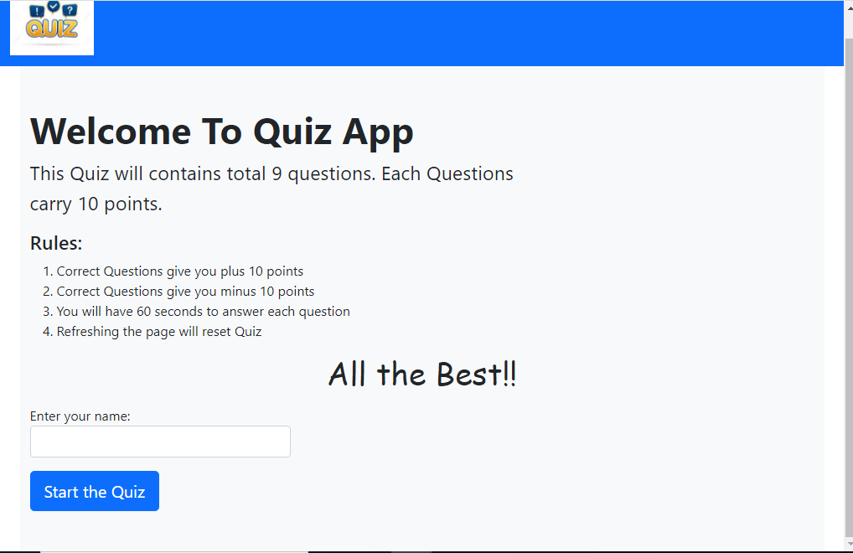

Fig.1 Welcome page of Quiz App